blank %}
The Guardian
‌ ‌ ‌ ‌ ‌ ‌ ‌ ‌ ‌ ‌ ‌ ‌ ‌ ‌ ‌ ‌ ‌ ‌ ‌ ‌ ‌ ‌ ‌ ‌ ‌ ‌ ‌ ‌ ‌ ‌ ‌ ‌ ‌ ‌ ‌ ‌ ‌ ‌ ‌ ‌ ‌ ‌ ‌ ‌ ‌ ‌ ‌ ‌ ‌ ‌ ‌ ‌ ‌ ‌ ‌ ‌ ‌ ‌ ‌ ‌ ‌ ‌ ‌ ‌ ‌ ‌ ‌ ‌ ‌ ‌ ‌ ‌ ‌ ‌ ‌ ‌ ‌ ‌ ‌ ‌ ‌ ‌ ‌ ‌ ‌ ‌ ‌ ‌ ‌ ‌ ‌ ‌ ‌ ‌ ‌ ‌ ‌ ‌ ‌ ‌ ‌ ‌ ‌ ‌ ‌ ‌ ‌ ‌ ‌ ‌ ‌ ‌ ‌ ‌ ‌ ‌ ‌ ‌ ‌ ‌ ‌

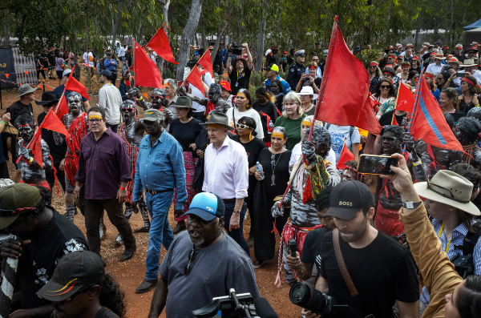

Dear supporter
A year ago opinion polls showed the Indigenous voice referendum had overwhelming voter approval.
Now, as the prime minister names the referendum date, the modest proposal – that Indigenous Australians be recognised in the constitution and empowered to advise policymakers on issues affecting them – is tangled in polarising attacks and unrelated allegations that threaten to derail decades of work towards reconciliation.
The referendum’s proposition was always going to be scrutinised and debated, as any change to the constitution should be.
But when Anthony Albanese announced the proposed wording at Garma 2022, flanked by then opposition Indigenous affairs spokesperson Julian Leeser “in a spirit of bipartisanship”, it was hard to imagine just how politicised and divisive the “debate” would become.
At first the questions raised were genuine points of discussion. Some constitutional conservatives, for example, fretted that a constitutionally embedded voice would open the door to legal challenges, a legitimate point to examine, although their concerns were countered by a majority of constitutional experts and also the solicitor general. Some took issue with wording that allowed the voice to make representations on a broad range of issues, not only on matters directly pertaining to Indigenous disadvantage.
Others, like Senator Lidia Thorpe, railed at the plan for being ineffective and not going far enough.
But after Peter Dutton locked the Coalition against the voice, parts of the no campaign appeared to take the advice of Frank Underwood, the fictional president in the TV drama House of Cards, when things weren’t going his way: “If you don’t like how the table is set, turn over the table.”
The straightforward referendum questions were stripped of context and meaning and conflated with unrelated, racially charged assertions, the actual pros and cons lost in the confusion.
Advised by slick US-based conservative marketing and fundraising campaigners and enthusiastically amplified by rightwing Australian media, the no case created a wildfire of online outrage, simplistic misrepresentation and false claims of hidden intent.
The voice would be a “Canberra’’ body, populated by “elites’’, they said, even though the whole idea was to give true representation to communities. The voice concealed a “secret” plan to force the negotiation of a treaty, they claimed. Given that the slogan of the Uluru statement from the heart was “voice, treaty, truth” this aspiration was hardly hidden, but it was always a separate, possible future process.
The voice would require landowners to “pay the rent” to “Aboriginal councils”, it was alleged even though the idea has nothing to do with the referendum and the voice would be a nonbinding advisory body which would never be able to enforce such a suggestion, were it ever to be made.
The Coalition is now raising “vote-rigging” claims about the long-established rules for referendum ballots, despite voting in favour of the enabling legislation that might have changed those rules earlier this year and despite the claim being “completely and utterly” rejected by the electoral commission.
The attacks against yes campaigners have at times become shockingly personal and the no campaign has refused to disavow offensive and racially charged statements from its own office holders.
And yet it insists division is caused by the voice proposition itself – the culmination of years of thought and goodwill discussions about how to advance Australian unity and shift Indigenous disadvantage – and not by the campaign they are waging against it. The “divisive” line worked in the focus groups, the no campaign says and, according to the published polls, it is indeed a claim gaining traction.
The speed and virality of the no attack seemed to catch the yes side flat-footed. Determined to run a positive campaign, and to not get side-tracked, it left claims unanswered. Because the referendum is asking Australians to vote on the principle of a voice, with its exact makeup to then be determined by parliament, the detail was, by definition, unexplained, leading to the charge that Australians are being asked to vote for a “blank cheque”.
But the no campaign has no clear alternative plan on the table. Dutton supports local and regional voices, with no explanation as to how what they say might be heard. The National party is unsure about even that idea. Neither can explain how the alleged “divisiveness” of a voice only applies if the institution is enshrined in the constitution, but somehow does not apply if it is legislated. Nor is it clear why they oppose this change to the constitution on the basis that it “divides us by race” but happily accept the existing constitutional race power.
The no camp says the voice is a “power grab” by leftwing activists, despite being developed through deep consultation with politicians from all parties, despite still being backed by prominent Liberals in and out of parliament, and despite having no power other than the proffering of advice.
But all these obvious contradictions are at risk of being drowned out by the slogan “Say no to the divisive voice”.
At the recent CPAC conference, Matthew Sheahan, the director of the conservative campaign group Advance, boasted that his campaign had taken advantage of voter confusion to “shape the conversation” and get the government “caught up” in the issues it raised.
He’s right. They have.
Australians now have six weeks to hear the arguments for and against the proposition they are actually being asked to vote for, an idea described by the Uluru statement as a chance to embrace a “fuller expression of Australia’s nationhood”.
It is a decision with consequences far beyond immediate partisan advantage, above all for the lives of Indigenous Australians. It is a decision that should be taken carefully, with consideration of the arguments rather than slogans or memes.
This is a decision that deserves to be made on the basis of facts, not fear. It’s thanks to supporters like you that we can make this possible through comprehensive, independent and reliable reporting.
Lenore Taylor
Editor
Guardian Australia



